LARC Social Media Resources

Sharing Colorado’s Success Story
Thank you for your support in sharing Colorado’s LARC success story. In addition to the social media content and suggested images below, please browse the recognition section of our website to post your reflections about the national media coverage related to Colorado’s LARC program and add the hashtag #LARC4CO.

Sample Text

Theme: Keeping Colorado a leader in public health
[Rationale: These posts are meant to engage national public health conversations and lead other public health leaders to the LARC4CO website to learn about the program. They also help garner local and legislative awareness/support by showing Colorado’s leadership.]

Twitter
- [Images1&2 below]: By investing in the most effect forms of #familyplanning, #coleg has made Colorado a leader in #publichealth. [link to: LARC FACT SHEET] #cohealth #LARCs #LARC4CO
- [Image 4 below] Bi-partisan support and broad community support have made #LARC4CO a national model for effective #publichealth programs. Let’s keep working together for #cohealth! http://larc4co.org
#LARCs #coleg
- [image 5 below]: This is what #publichealth success looks like. #COleg saved Colorado between $66.1-$69.6 million in avoided public assistance costs with #LARCs. http://larc4co.org #LARC4CO #cohealth
- [Image 3 below]: Thanks #coleg for your leadership in Colorado’s #publichealth success story. In seven years, access to #LARCSs have dramatically reduced Colorado’s unintended pregnancies and abortion rates and saved Colorado money. [link to fact sheet] [https://www.LARC4CO.org/LARC4CO-one-sheet-08-20-18.pdf] #publichealth #LARC4CO #cohealth #familyplanning

Facebook
- [Images 1, 2, and 5 below]: Bi-partisan support of affordable Long-Acting Reversible Contraceptives (LARCs) have made Colorado a leader in public health, dramatically reducing Colorado’s unintended pregnancies and abortion rates, and saving the state of Colorado millions of dollars. Let’s ensure Colorado remains a national public health leader. Learn more: http://larc4co.org.
- [Images 1 and 2 below]: Continued access to LARCs ensure that Colorado remains a national leader, reducing unintended pregnancy, saving the state money, and securing a healthy future for thousands of Colorado women and their families. Learn how you can help ensure Colorado’s success continues: http://larc4co.org.
- [Image 3 below]: New lawmakers and candidates for office need to know about Colorado’s biggest public health success. Make sure they know how important their continued support of affordable LARCs are to Colorado women and the state budget. Contact your legislator to share your support of Colorado’s LARC program. https://openstates.org/find_your_legislator/.

Theme: Supporting choice equity
[Rationale: These posts address the issue of making all forms of contraceptive affordable, so that all women have a choice of what works best for them. The messages could be built on to include promoting access to all types of information if needed with the gag rule.]

Twitter
- [Images 3 & 4 below]: I [or my organization] support[s] keeping #LARCs affordable, so every woman has the option to choose the most effective contraceptive available. #healthequity #coleg #cohealth #LARC4CO #reprohealth [http://LARC4CO.org]
- [Image 3 below]: 51,427 women have chosen the most effective and reliable contraceptive available since #LARC4CO started. Let’s ensure #LARCs remain accessible to every woman. http://larc4co.org #healthequity #reprohealth #cohealth
- [Images 4 & 5 below]: Do you have a new legislator in your district? Make sure they know that you support affordable #LARCs so that every woman has access to the most effective #contraceptives available: https://openstates.org/find_your_legislator/. Learn more at http://larc4co.org. #LARC4CO #reprohealth #cohealth #maternalhealth
- Personal stories are critical to continuing broad support for Colorado’s successful #LARC4CO program, which makes #LARCs affordable to all women. If #LARCs have changed your life, share your story at http://larc4co//contactus/. #cohealth #newmom #reprohealth #advocate #publichealth

Facebook
- [Image 3 below]: 51,427 Colorado women have chosen a Long Acting Reversible Contraceptives (LARCs), the most effective and reliable contraceptive available, since #LARC4CO started. Let’s ensure #LARCs remain accessible to every woman. http://larc4co.org
- [Images 1 & 2 below]: All women should have access to the full range of contraceptive methods available to support their family planning choices. The Colorado LARC program has made a huge impact in the lives of Colorado women and their families. Learn how you can continue the support of this successful program: http://larc4co.org.

Images to Share
The images below are also available for download at www.LARC4CO.org/get-involved.

Image 1: Data about women ages 15-19
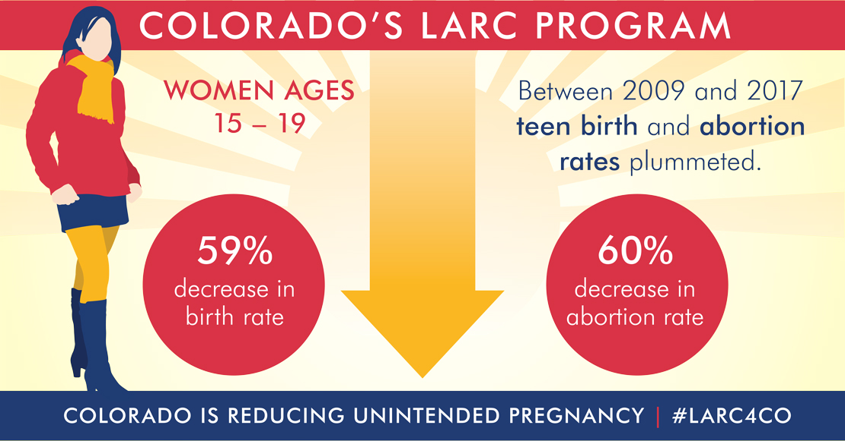

Image 2: Data about women ages 20-24
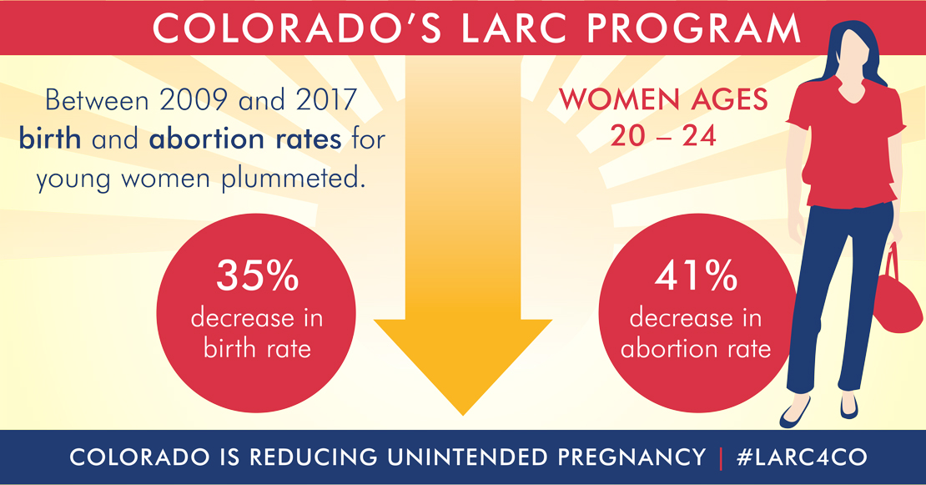

Image 3: LARC Empowers Colorado Women
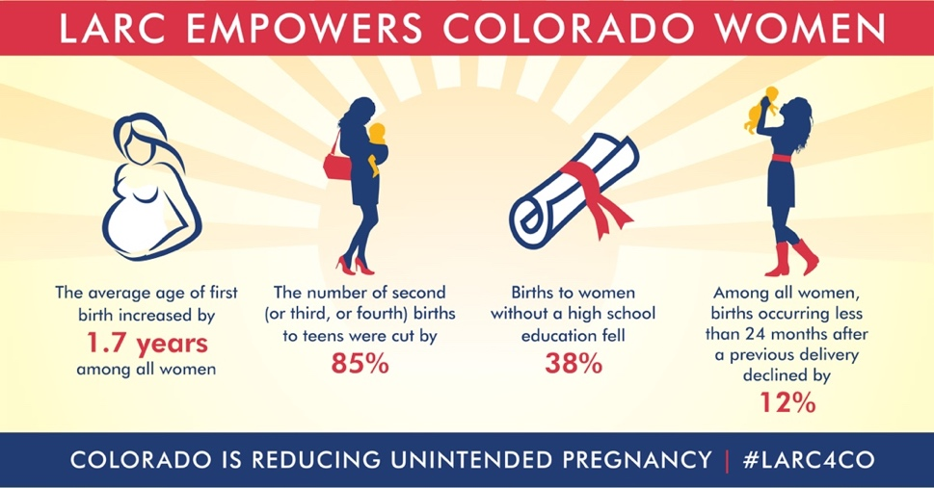

Image 4: LARCs Work. LARCs Change Lives. LARCs Save Colorado A Lot of Money
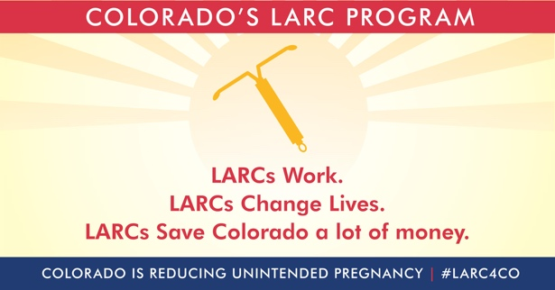

Image 5. LARCs Save Colorado A Lot of Money


